*Pizza Sales SQL Queries Documentation*

1. KPI’s
2. **Total Revenue :**

SELECT SUM(total_price) AS Total_Rev FROM Pizza_Sales_FinalSheet

**OUTPUT:**

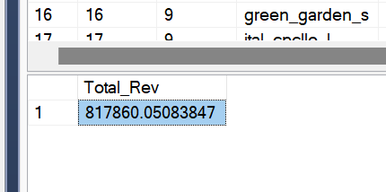

1. **Average Order Value :**

SELECT SUM(total_price) / COUNT(DISTINCT order_id) AS Avg_Order_Value FROM Pizza_Sales_FinalSheet

**OUTPUT:**

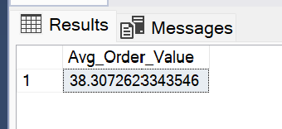

1. **Total Pizza Sold :**

Select Sum(quantity) As Total_Pizza_Sold From Pizza_Sales_FinalSheet

**OUTPUT:**

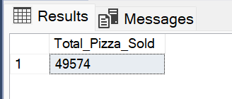

1. **Total No. Of Orders Placed:**

Select COUNT(DISTINCT order_id) As Total_Orders From Pizza_Sales_FinalSheet

**OUTPUT:**

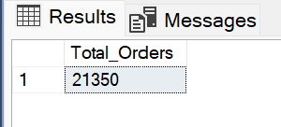

1. **Average Pizzas per Order :**

SELECT SUM(quantity) / COUNT(DISTINCT order_id) AS AVG_Pizza_PerOrder

FROM Pizza_Sales_FinalSheet

**OUTPUT:**

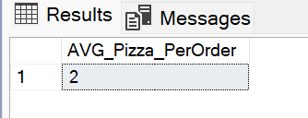

The pizzas can be in decimal numbers too hence, Using CAST function to change the data type of Numerator and denominator to get decimal numbers as precise as possible.

SELECT CAST(SUM(quantity) AS DECIMAL(10,2)) /

CAST(COUNT(DISTINCT order_id) AS DECIMAL(10,2))

AS AVG_Pizza_PerOrder

FROM Pizza_Sales_FinalSheet

**OUTPUT:**

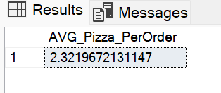

***PROBLEM STATEMENTS***

***CHARTS REQUIERED***

1. **Daily Trend for Total Orders:**

SELECT DATENAME(DW, order_date) AS Order_Day,

COUNT(DISTINCT order_id) AS Total_Orders

FROM Pizza_Sales_FinalSheet

GROUP BY DATENAME(DW, order_date)

ORDER BY Total_Orders

**OUTPUT:**

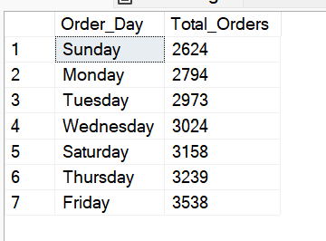

1. **Monthly Trend for Total Orders:**

SELECT DATENAME(MONTH,order_date) AS Month_Name,

COUNT(DISTINCT order_id) AS Total_Orders

FROM pizza_sales21

GROUP BY DATENAME(MONTH, order_date)

ORDER BY Total_Orders DESC

**OUTPUT:**

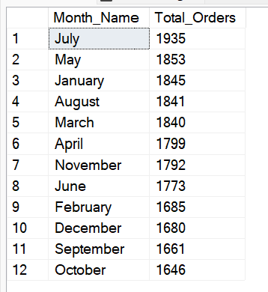

1. **Percentage of Sales by Pizza Category :**

SELECT pizza_category, SUM(total_price) * 100 /

(SELECT SUM(total_price) AS Total_Revenue

FROM Pizza_Sales_FinalSheet) AS Perc_Of_Sale

FROM Pizza_Sales_FinalSheet

GROUP BY pizza_category

**OUTPUT:**

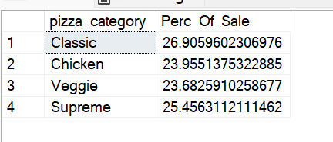

/* we can add the filters in the same query to find out the same percentage of total sale by using WHERE Clause for both the query & Subquery.*/

Example : Percentage of Sale of Month January by Pizza Category

SELECT pizza_category, sum(total_price) *100 /

(SELECT SUM(total_price)

FROM Pizza_Sales_FinalSheet

WHERE MONTH(order_date) = 1) AS PCT

FROM Pizza_Sales_FinalSheet

WHERE MONTH(order_date) = 1

GROUP BY pizza_category

**OUTPUT:**

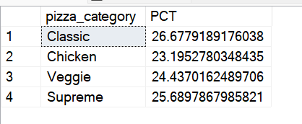

1. **Percentage of Sale by Pizza Size :**

SELECT pizza_size, SUM(total_price) AS Total_Revenue,

CAST(SUM(total_price) *100 / (SELECT SUM(total_price) FROM Pizza_Sales_FinalSheet) AS DECIMAL(10,2)) AS PCT

FROM Pizza_Sales_FinalSheet

GROUP BY pizza_size

ORDER BY pizza_size

**OUTPUT:**

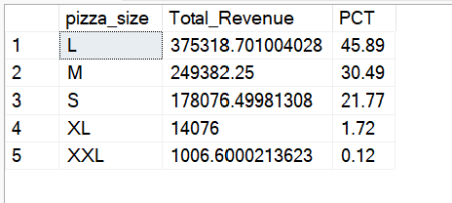

****We can add the WHERE Clause and DATEPART function to fetch the data of January Month First Quarter.

SELECT pizza_size, SUM(total_price) AS Total_Revenue,

CAST(SUM(total_price) *100 / (SELECT SUM(total_price) FROM Pizza_Sales_FinalSheet WHERE DATEPART(Quarter, order_date) = 1) AS DECIMAL(10,2)) AS PCT

FROM Pizza_Sales_FinalSheet

WHERE DATEPART(Quarter, order_date) = 1

GROUP BY pizza_size

ORDER BY pizza_size

**OUTPUT:**

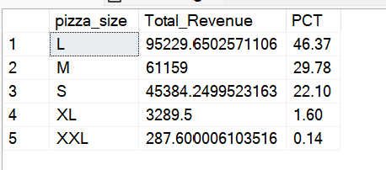

1. **TOP 5 Best Seller Pizza by Total Sale :**

SELECT TOP 5 pizza_name, SUM(total_price) AS Total_Revenue

FROM Pizza_Sales_FinalSheet

GROUP BY pizza_name

ORDER BY Total_Revenue Desc

**OUTPUT:**

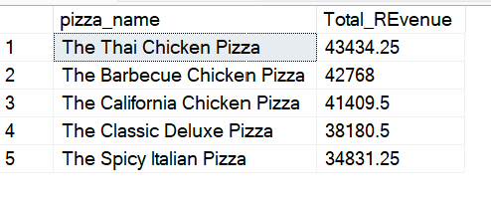

1. **Bottom 5 Worst Pizza Sold with Revenue :**

SELECT TOP 5 pizza_name, SUM(total_price)AS Total_REvenue

FROM Pizza_Sales_FinalSheet

GROUP BY pizza_name

ORDER BY Total_REvenue ASC

**OUTPUT:**

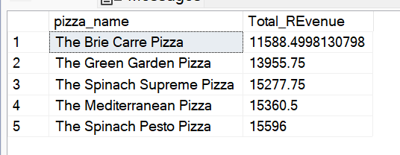

1. **Best Seller TOP 5 Pizzas by Quantity :**

SELECT TOP 5 pizza_name, SUM(quantity)AS Total_Quantity

FROM Pizza_Sales_FinalSheet

GROUP BY pizza_name

ORDER BY Total_Quantity DESC

**OUTPUT:**

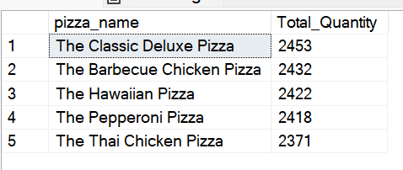

1. **Bottom 5 Worst Pizza name by Quantity :**

SELECT TOP 5 pizza_name, SUM(quantity)AS Total_Quantity

FROM Pizza_Sales_FinalSheet

GROUP BY pizza_name

ORDER BY Total_Quantity ASC

**OUTPUT:**

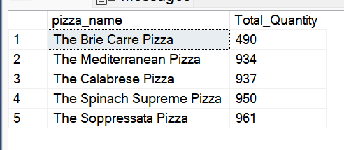

**The Project Summery:**

1. Orders are highest on the weekends i.e. Thursday, Friday and Saturday Evenings.
2. Maximum No. of Orders are recorded in the Month of July and January.
3. The Pizza Category : The Classic Pizza Category contributes highest to the Revenue and Orders.
4. The Pizza Size : The Large Pizzas contributes maximum to the total revenue.
5. Top Seller : The Thai Chicken Pizza Contributes maximum to the Revenue followed by The Barbeque Chicken Pizza, The California Chicken Pizza, The Classic Deluxe and The Spicy Italian Pizza.
6. The Classic Deluxe Pizza contributes maximum in terms of Orders.
7. The Brie Carre Pizza is the one contributes least to the revenue and in terms of Orders.